**JOB PORTAL SYSTEM**

A project submitted to

**UKA TARSADIA UNIVERSITY**

in partial fulfillment of the requirements for the degree of

**Bachelor of Science**

in

**Information Technology**

for

**5 Years Integrated M.Sc.(IT)**

By

**PARTH GOTI**

(201706100110042)

**DHRUVI VAGHELA**

(201706100110122)

Guided by

**PREETI BHATT**

**ASSISTANT PROFESSOR**



**Babu Madhav Institute of Information Technology**

### Uka Tarsadia University

### Bardoli – 394350

### November 2019

**CERTIFICATE**

This is to certify that **PARTH GOTI (201706100110042), DHRUVI VAGHELA (201706100110122)** has submitted project entitled **“JOB PORTAL”** as the partial fulfillment for the award of the degree of Bachelor of Science in Information Technology for 5 Years Integrated M.Sc.(IT) in 2019 – 2020.

**Date:**

**Place:**

**PREETI BHATT Dr. Jitendra Nasriwala**

Guide Programme Coordinator,

**External Examiner**



**Babu Madhav Institute of Information Technology,**

**Uka Tarsadia University,**

**Bardoli – 394350**

**Acknowledgements**

Every project is a masterpiece of hard work and sincere effort of all those who are involved in the project. we present this report on the completion of our project we would like to express our sincere thanks to all those who have guided, advised, inspired and supported us during the work on project.

We are extremely grateful to **Mrs. Preeti Bhatt,** project guide, for the tremendous help that she gave us in project. We are also Extremely grateful to her for her encouragement throughout this project

Last but not least thanks to all those who have directly or indirectly contributed to our success.

Chapters

1.Introduction 1

1.1 Purpose: 1

1.2 Scope: 1

2.System Analysis 2

2.1 Identification Of needs 2

2.2 Technologies Used 2

2.3 Functional Requirements 3

2.4 Non-Functional Requirements 4

2.5 Modules: 4

2.6 User characteristics 5

2.7 Use case of Job Portal System 6

3.System Design 11

3.1 Data Dictionary 11

3.2 User Interface Design 16

4.System Testing 25

4.1 Test Cases 25

5.Future Enhancement of The Project and Conclusion 28

6.References 28

7.Bibliography 28

# 1.Introduction

## 1.1 Purpose:

* The purpose of the project is to build an application program to reduce the manual work for managing the Interview , Employer , Post Job , Call Letter .It tracks all the details about the Call Letter ,Employer Registration , Search Job.

## 1.2 Scope:

* In this system Catalog section will be visit by any one and Job Portal system accessed by only owner of the company and HR(Job Provider) of the company.

# 2.System Analysis

## 2.1 Identification Of needs

* The present manual system is based on paperwork which contain several redundant documentation.
* Important data is lost in paperwork.
* The present system provide slow services. So to remove limitation we proposed to develop a web system that will manage job and job seekers.

## 2.2 Technologies Used

* ***Client Side:***
  + - HTML (mixed with asp.net)
    - CSS
* ***Server Side:***
  + - ASP.NET
    - C#
* ***Database Tool:***
  + - SQL server 2008 R2

## 2.3 Functional Requirements

* ***Login and Registration:***
  + - Owner /HR(Job Provider) can login with their unique username or password.
    - Job Seeker can registration into the system and login with their username or password.
* ***Feedback:***
  + - Owner should be able to view the feedback of job seeker.
    - Job seeker should be able to give a feedback.
* ***Profile:***
  + - Owner and Job Provider(HR) should be able to view the profile of job seeker.
* ***Add Job description:***
  + - Job provider(HR) should be able to add job description.
* ***Update new Job vacancy:***
  + - Job provider(HR) should be able to update new job vacancy
* ***Remove Job:***
  + - Job provider(HR) should be able to remove the job.
* ***Search and apply Job:***
  + - Job seeker should be able to search and apply for job.
    - Owner and Job Provider(HR) should be able to change status (approve/reject) of the job application.
    - Job Seeker should be able to view the status(approve/reject) of job application.

## 2.4 Non-Functional Requirements

* ***Accessibility:***
  + - The job portal system will provide restriction against unauthorized access.
    - Job seeker can not view the data of Job provider(HR).

## 2.5 Modules:

* ***Module1: Registration and Authentication***
  + - In this module owner and HR can authenticate via their unique username and password into the system. In this module user can view their profile details (like username, contact no, address) and user can also change the password in this module. In this module owner can add, update, delete job details.
* ***Module2: Job and description***
  + - Job and about Job(description of job) entered by HR(job provider) into the system. Owner and HR(Job Provider) have rights in this system for add, update, delete. Visitor can only visit the web site and only see the job and description.
* ***Module3: Job Application***
  + - For applying a job Registration and login is compulsory for the Job Seeker. In Job Seeker Profile only job seeker can add, update, delete in their profile. Owner HR(Job Provider) can view only the application of job seeker.
    - Owner and Job Provider(HR) update the status of job application and Jobseeker can only view the status of job application.
* ***Module4: Feedback***
  + - Job seeker give the feedback into the system. Owner and HR(Job Provider) can only view the feedback of jobseeker.

## 2.6 User characteristics

* ***Owner/Admin:***
  + - Owner can updating a status. Owner should be able to view the feedback of job seeker. Owner can registration of HR(Job Provider) and view the profile of Job Seeker.
* ***HR(Job Provider):***
  + - HR(Job Provider) can login into the system.HR(Job Provider) can add, update or delete about job and its description.HR(Job Provider) can update the new Job vacancy.HR(Job Provider) can view the profile of job seeker.HR(Job Provider) can approve or reject the status of job application.
* ***Job Seeker:***
  + - Job seeker can registration and login into the system. Job seeker can view and search all types of jobs. Job seeker can apply for job. Job seeker can view the status of Job Application approve/reject.
* ***Visitor:***
  + - Visitor can only show our site checked or view about the Jobs and description if it like that and apply for job then registration into the system.

## 2.7 Use case of Job Portal System

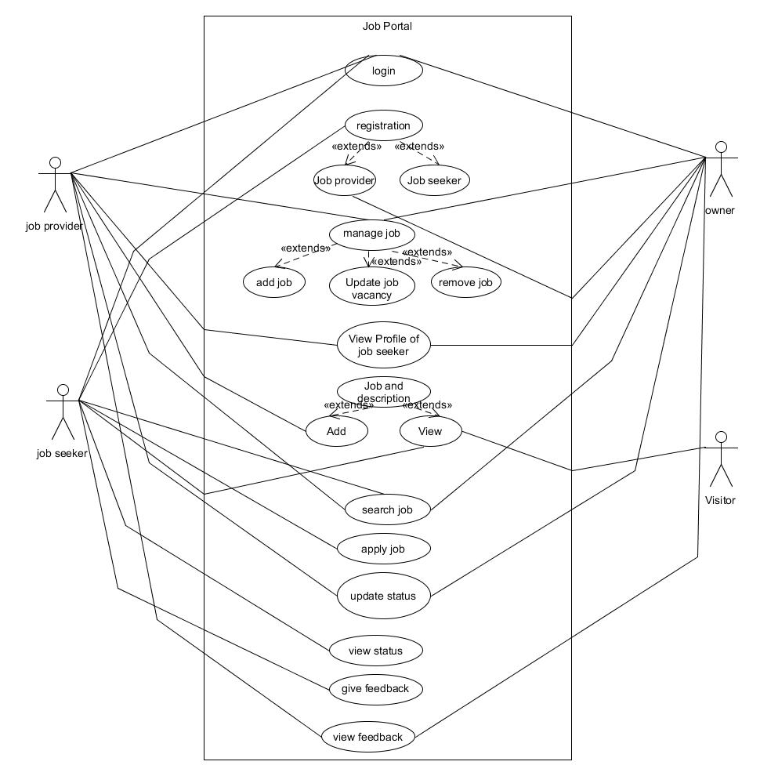

**2.8 Activity Diagrams:**

* ***Login***

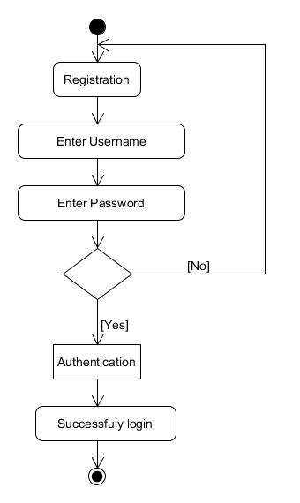

* ***Job Application***

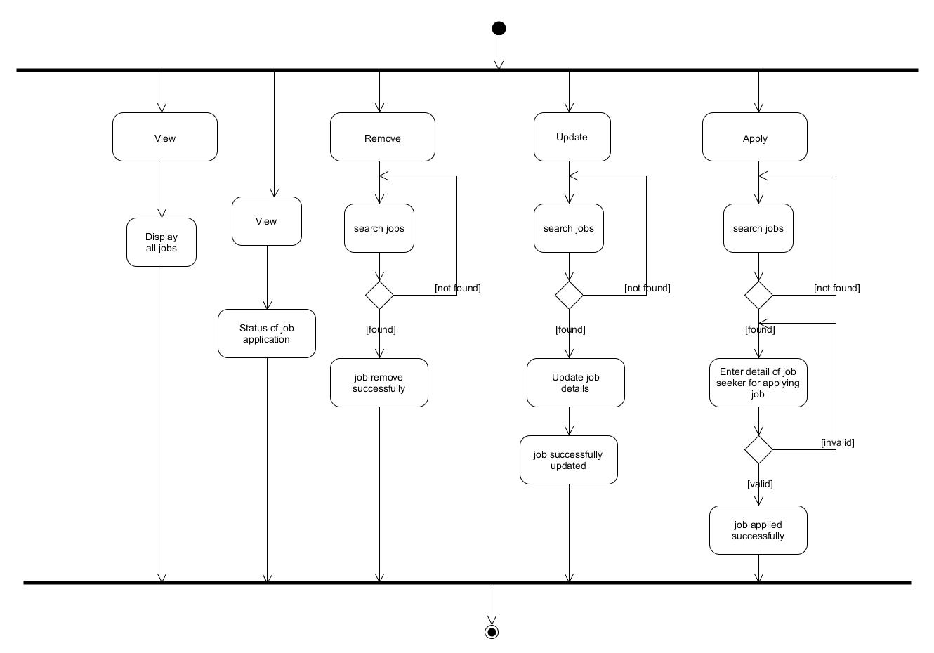

* ***Manage Job***

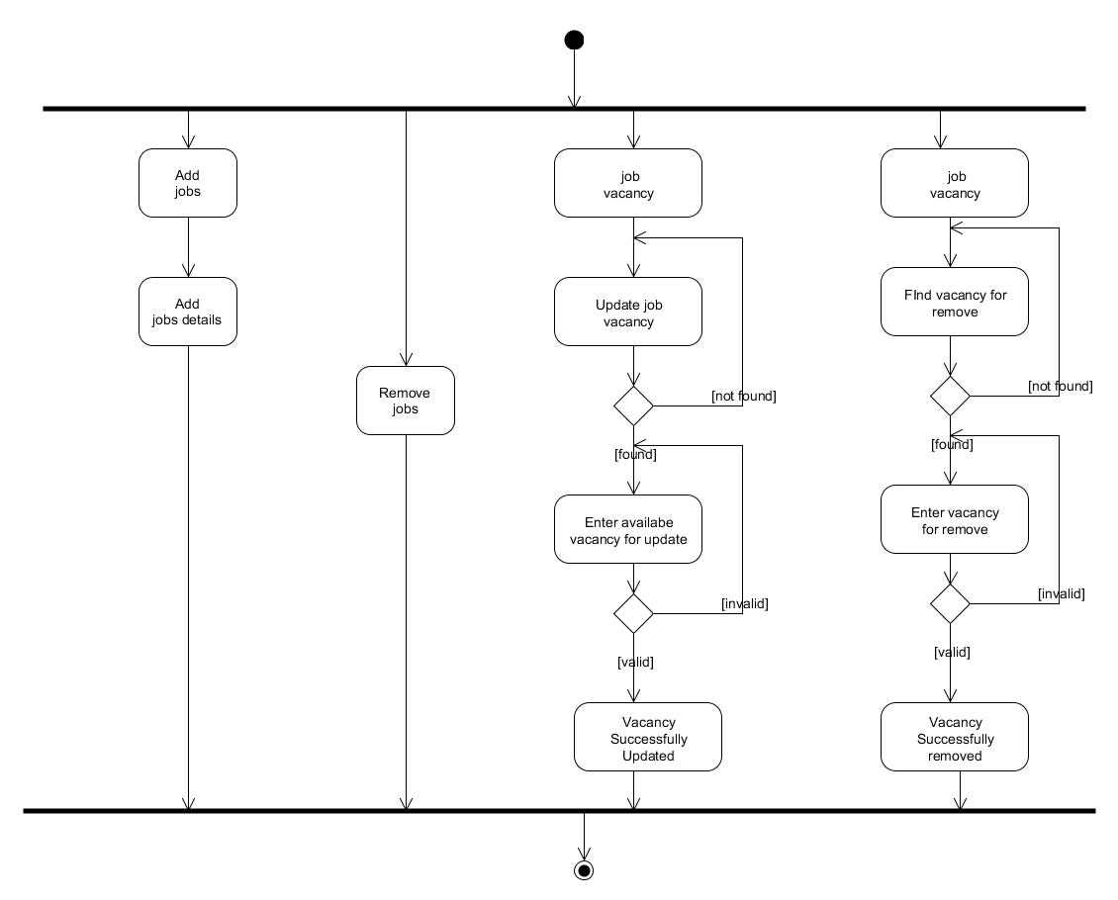

* ***Feedback:***

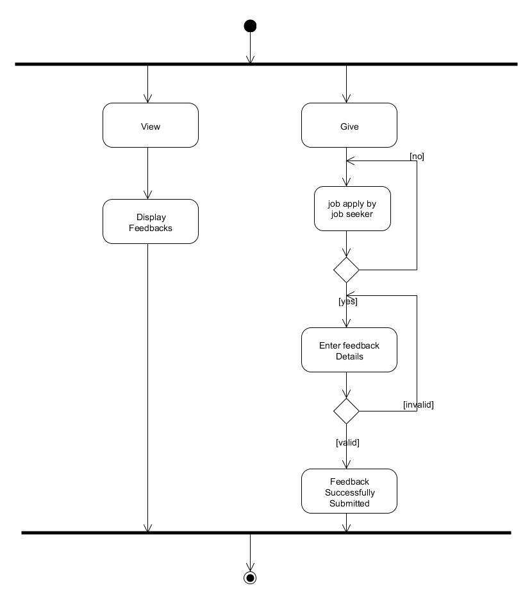

# 3.System Design

## 3.1 Data Dictionary

* ***Table Name: tblLogin***

|  |  |  |  |  |
| --- | --- | --- | --- | --- |
| Field Name | Data Type | Size | Constraint | Description |
| LogInId | int | 11 | Primary Key | It’s loginid for Owner,HR and Candidate. |
| Email | Varchar | 255 | Not Null | It’s having email id for login and authentication. |
| Password | Varchar | 12 | Not Null | Password of authenticate user whose login into the system. |
| User_type | Varchar | 1 | Not Null | It’s describe which type of user login into the system. |

* ***Table Name: tblUserInfo***

|  |  |  |  |  |
| --- | --- | --- | --- | --- |
| Field Name | Data Type | Size | Constraint | Description |
| UserInfoId | int | 11 | Primary Key | It’s contains userinfo id which is used system. |
| LogInId | int | 11 | Foreign Key | It’s contains loginid into the system. |
| Email | Varchar | 255 | Not Null | It’s contains email as username. |
| Fame | Varchar | 25 | Not Null | It’s Contains First Name. |
| Lname | Varchar | 25 | Not Null | It’s Contains Last Name. |
| Dob | Date |  | Not Null | It’s contains Date Of Birth. |
| State | Varchar | 30 | Not Null | It’s Contains State. |
| Gender | Char | 1 | Not Null | It’s Contains Gender of user. |
| Address | Varchar | 65 | Not Null | It’s Contains Address. |
| Resume | Varchar | 30 | Not Null | It’s contains pdf file for candidate or HR. |
| Hedu | Varchar | 30 | Not Null | It’s contains education of user. |
| Mobile_no | varchar | 10 | Not Null | It contains contact info of user. |
| Marital_status | Char | 1 | Not Null | It contains a marital status. |
| Department | Varchar | 30 | Not Null | It contains a department name |

* ***Table Name: tblApplication***

|  |  |  |  |  |
| --- | --- | --- | --- | --- |
| Field Name | Data Type | Size | Constraint | Description |
| ApplicationId | int | 11 | Primary key | It contains job id which is used in system by hr. |
| Jobid | int | 11 | Foreign key | It contains a job id. |
| ApplicantId | int | 11 | Foreign key | It contains id of job seeker id which is used in system. |
| Email | Varchar | 255 | Not Null | It contains user name for login into the system. |
| Status | Char | 1 | Not Null | It contains a name of which one is applied for job. |
| Remark | Varchar | 60 | Not Null | It contains a remark for approve or rejection. |

* ***Table Name: tblJobs***

|  |  |  |  |  |
| --- | --- | --- | --- | --- |
| Field Name | Data Type | Size | Constraint | Description |
| JobId | int | 11 | Not Null | It contains job id which is used in system. |
| title | Varchar | 30 | Not Null | It contains job name. |
| Job_type | Varchar | 40 | Not Null | It contains a job type |
| Location | Varchar | 60 | Not Null | It contains location. |
| Company | Varchar | 30 | Not Null | It contains company name. |
| Description | Varchar | 50 | Not Null | It contains description for job |
| Req_experience | Varchar | 20 | Not Null | It contains req experience for job |
| Expected_salary | Varchar | 30 | Not Null | It contains salary |
| JobCreatedByUserId | int | 11 | Not Null | It contains userid of which add a job. |

* ***Table Name: tblrating***

|  |  |  |  |  |
| --- | --- | --- | --- | --- |
| Field Name | Data Type | Size | Constraint | Description |
| Rid | int | 11 | Primary key | It contains rating id. |
| Loginid | int | 11 | Foreign key | It contains a login id. |
| User_type | Char | 1 | - | It contains User type |
| Star | int | 11 | - | It contains a no of star which is given by user out of 5. |
| Comment | Vachar | 25 | - | It contains a comment for rating. |

## 3.2 User Interface Design

* + ***home page:***

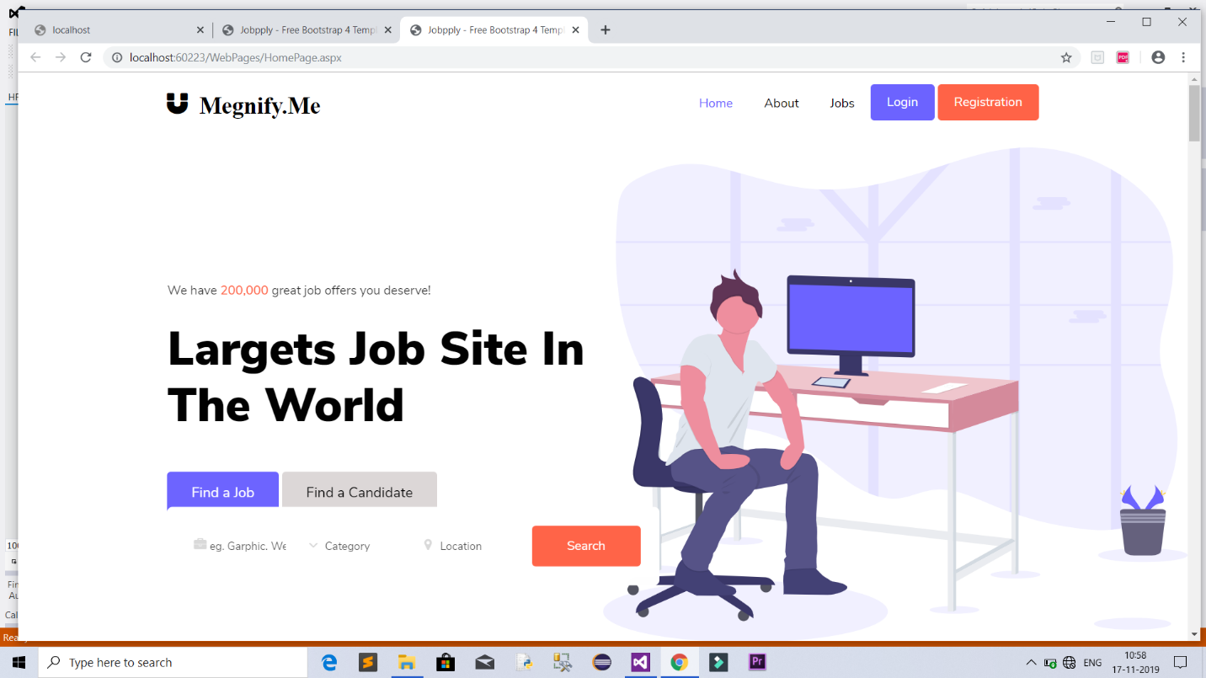

* + ***registration page:***

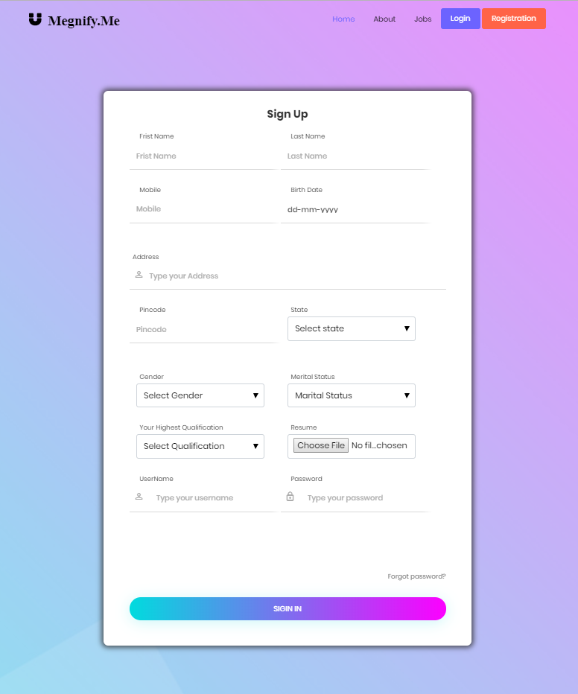

* + ***login page:***

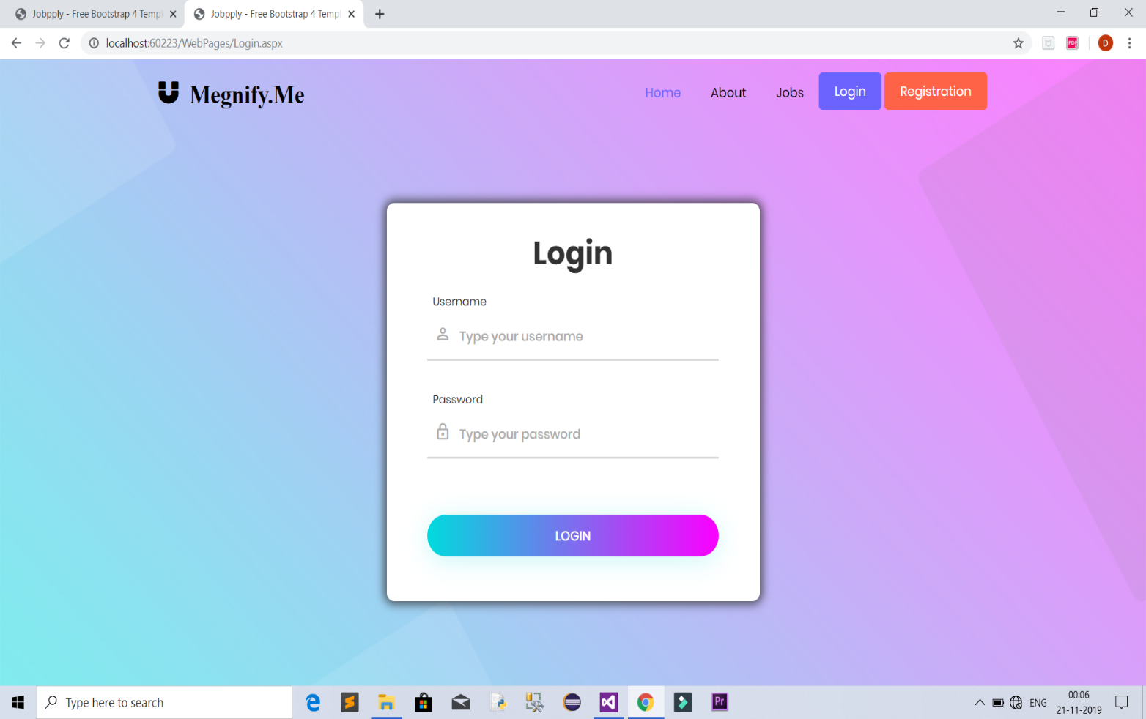

* + ***Candidate List:***

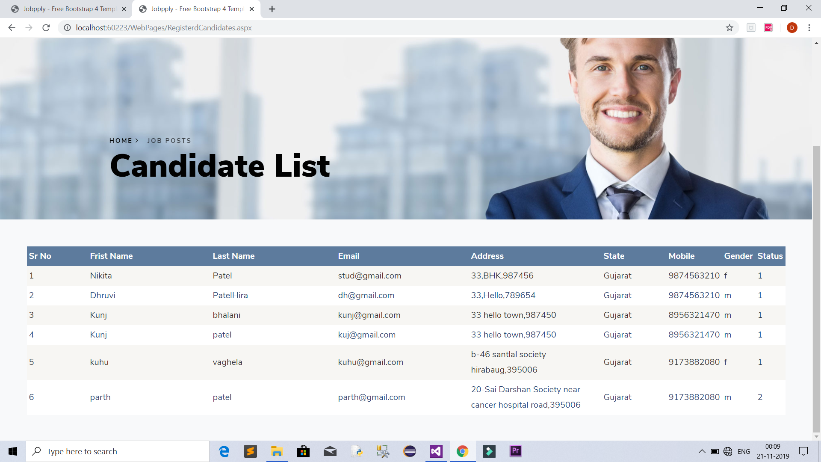

* + ***HR List:***

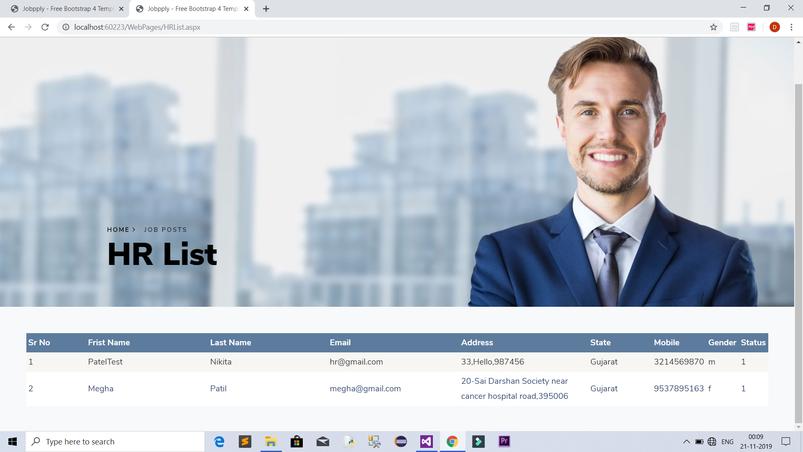

* + ***Application:***

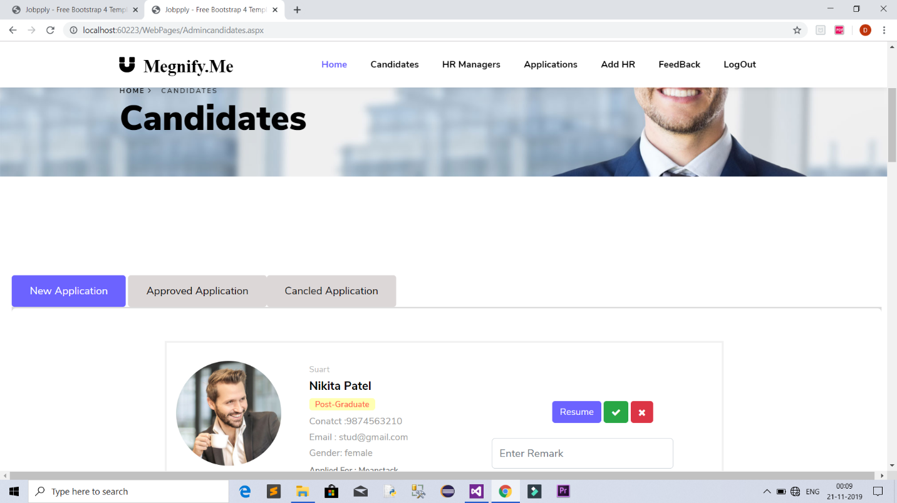

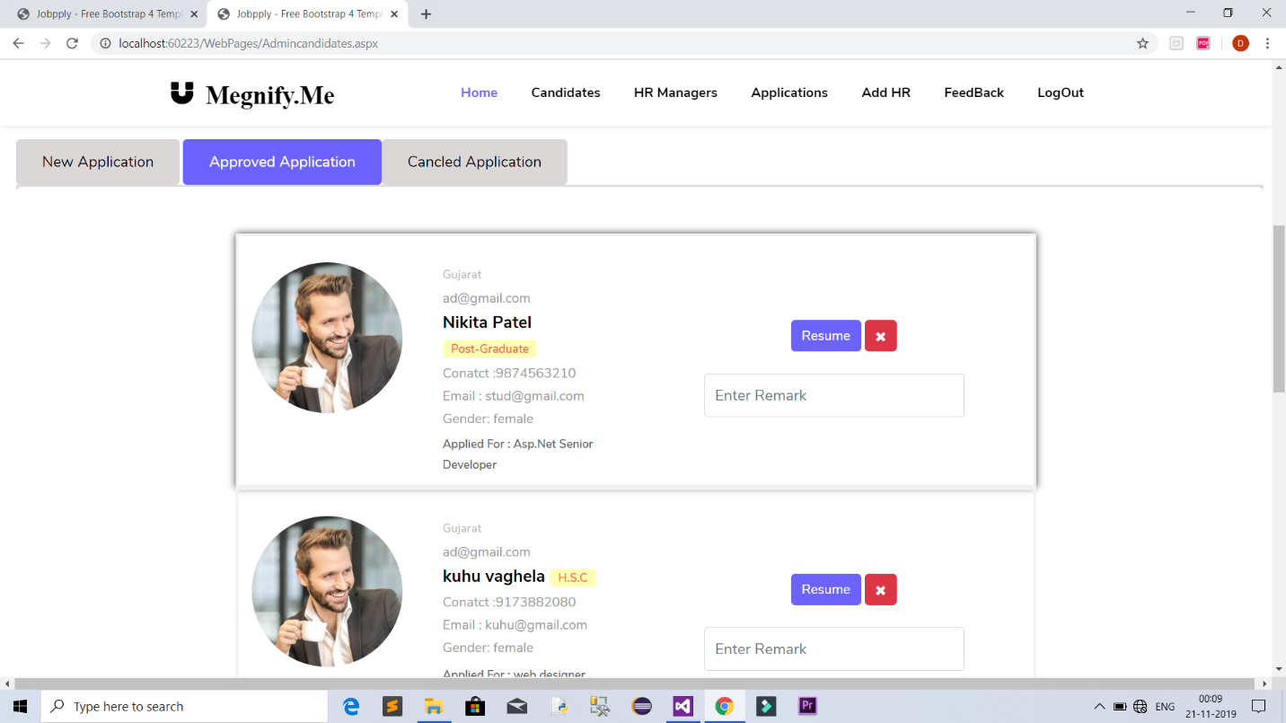

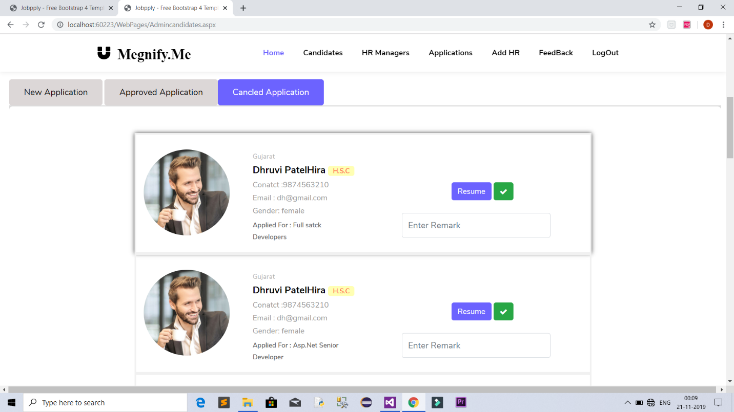

* + ***Rating:***

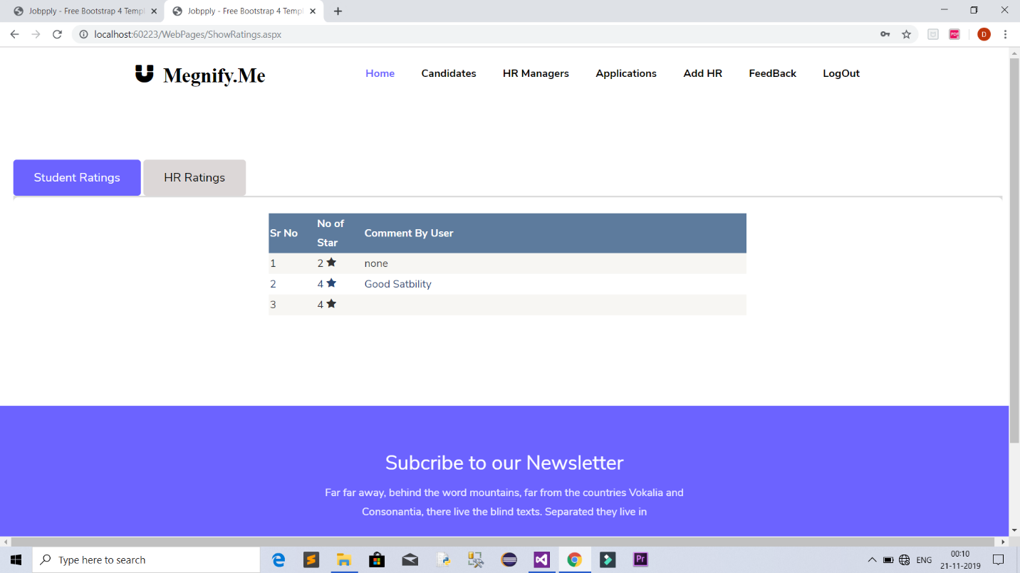

* + ***Jobs:***

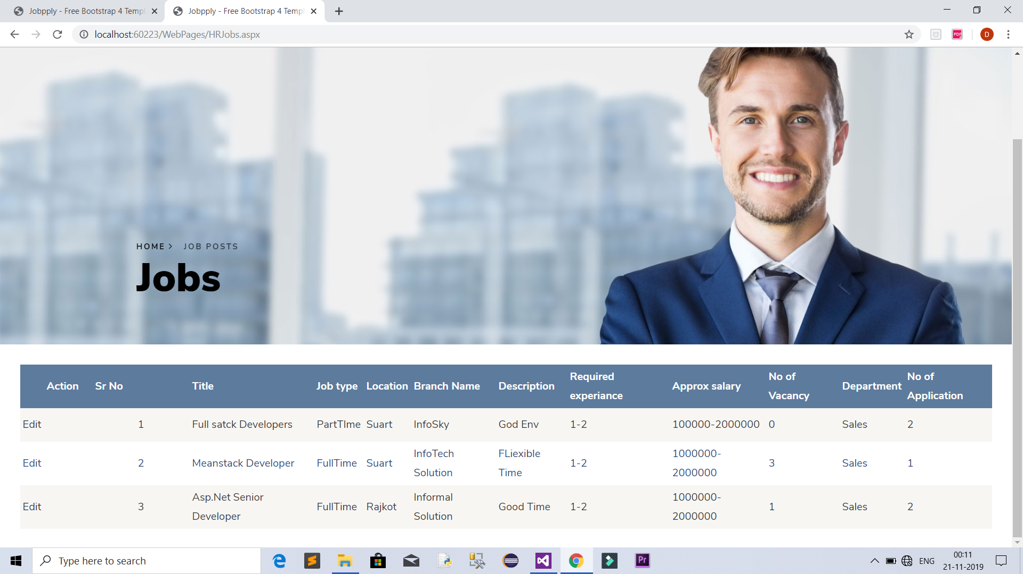

* + ***Add Job:***

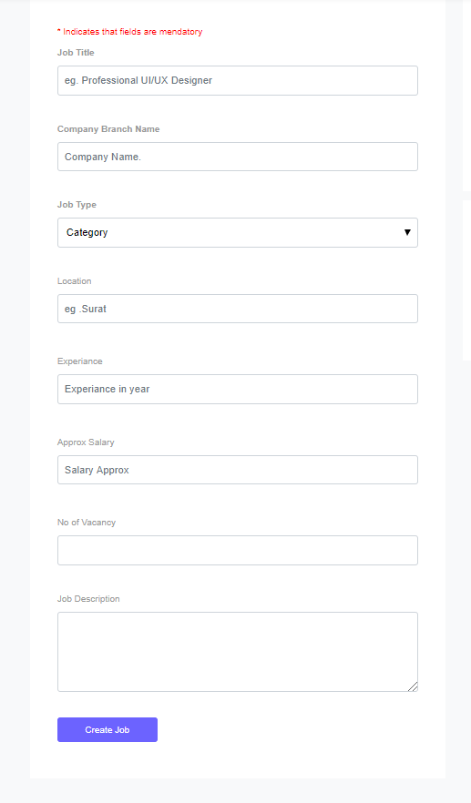

* + ***Profile:***

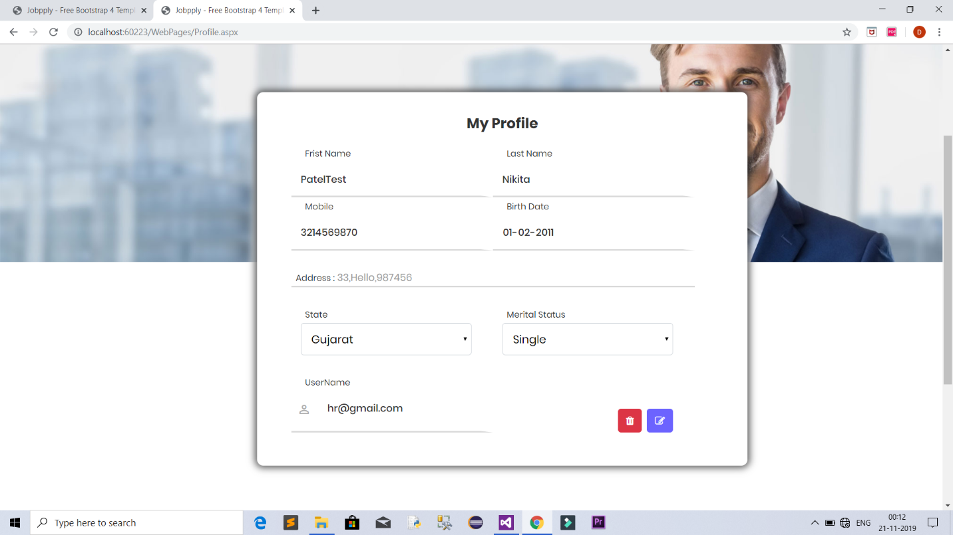

* + ***Feedback:***

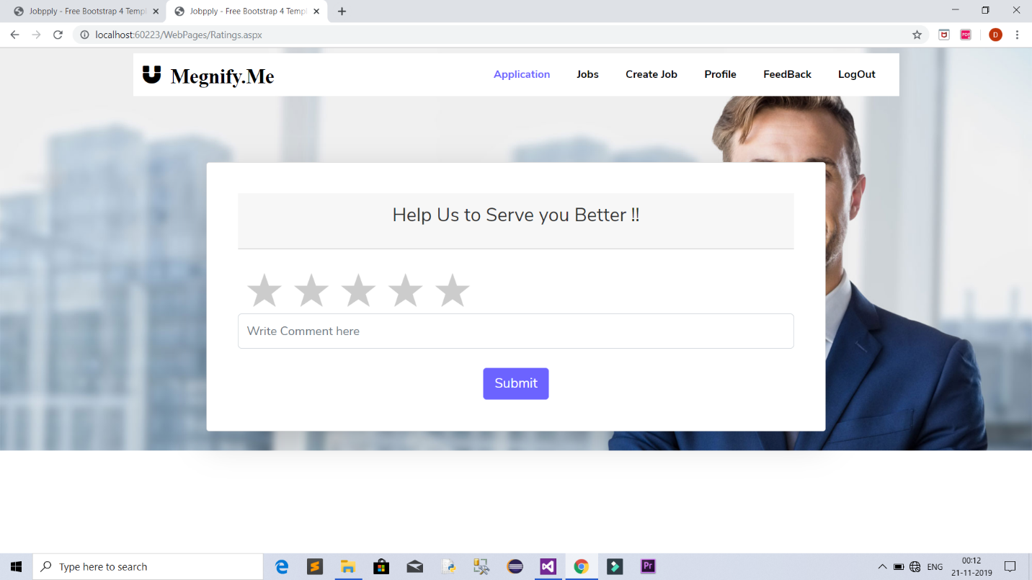

* + ***Apply for job:***

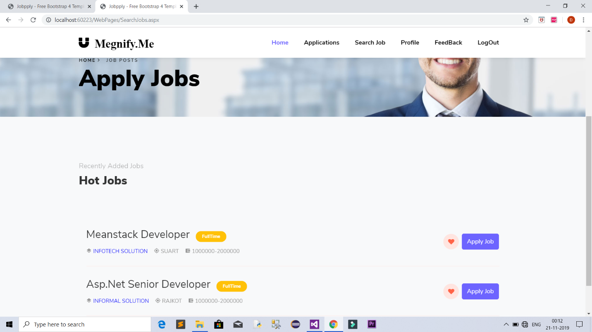

* + ***Applications of job seeker:***

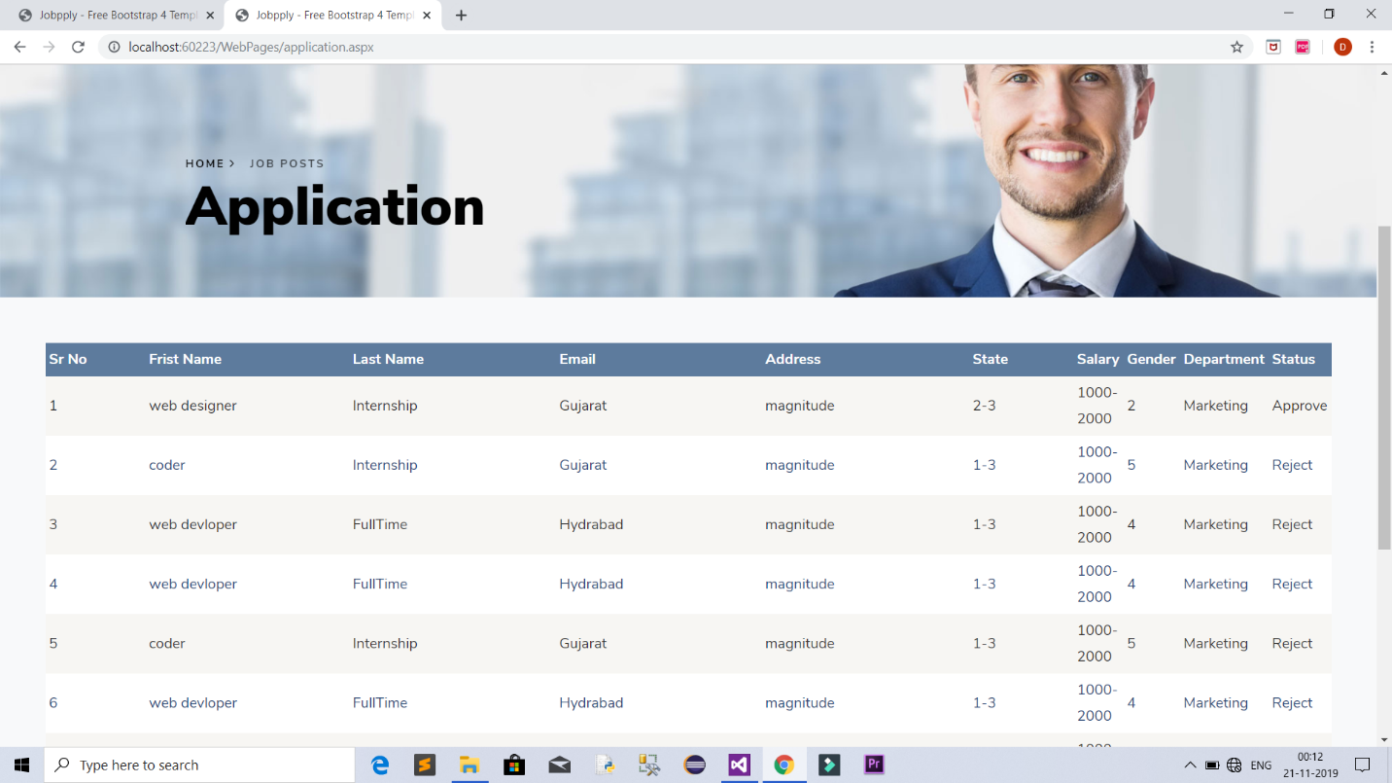

# 4.System Testing

## 4.1 Test Cases

* + ***Registration page:***

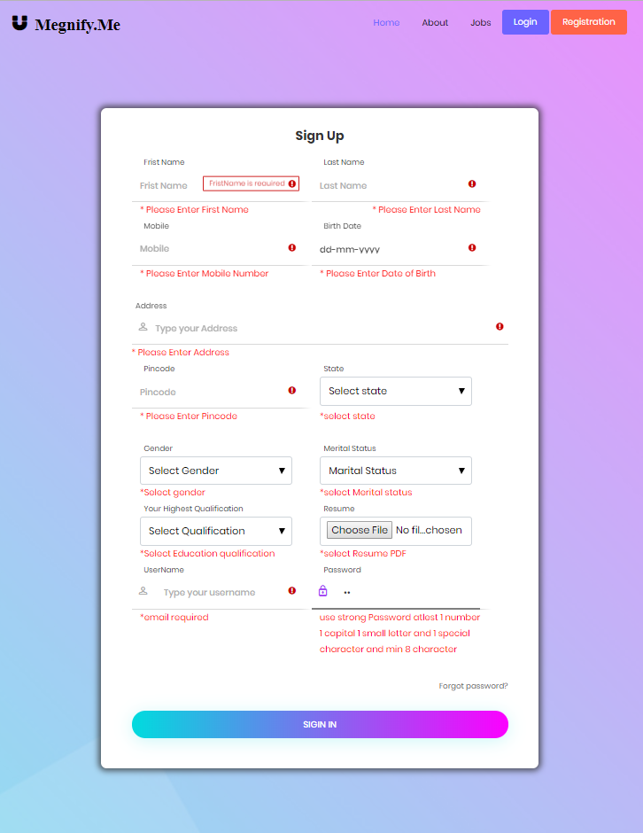

* + ***Login page:***

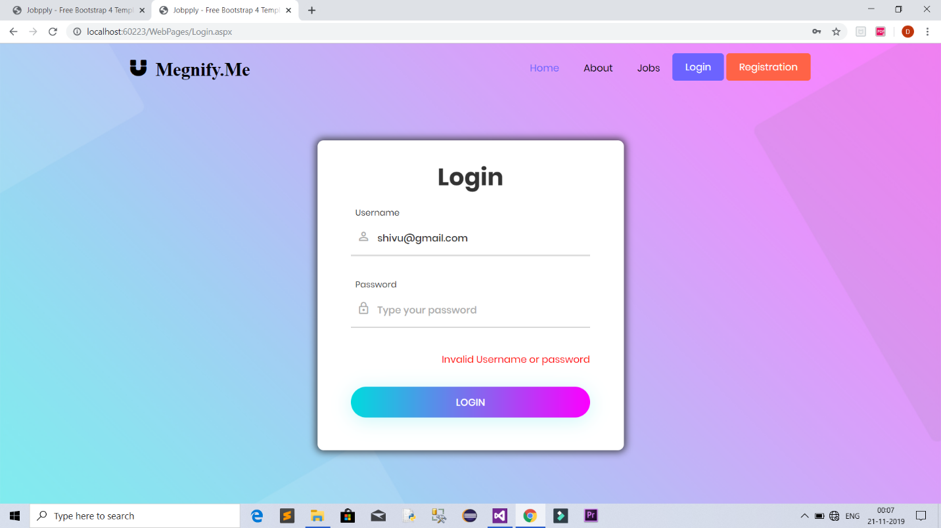

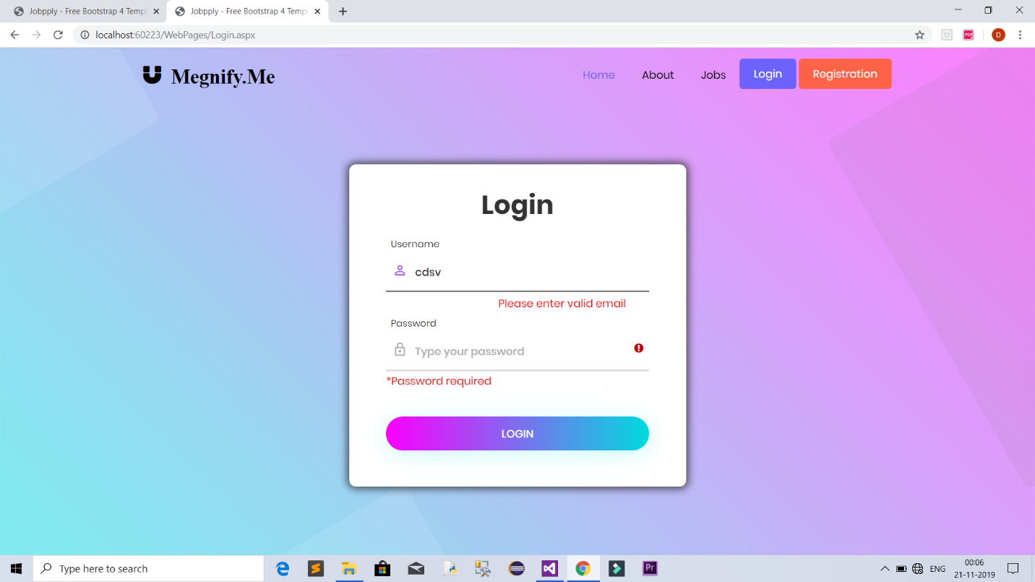

* + ***Approve or Reject page:***

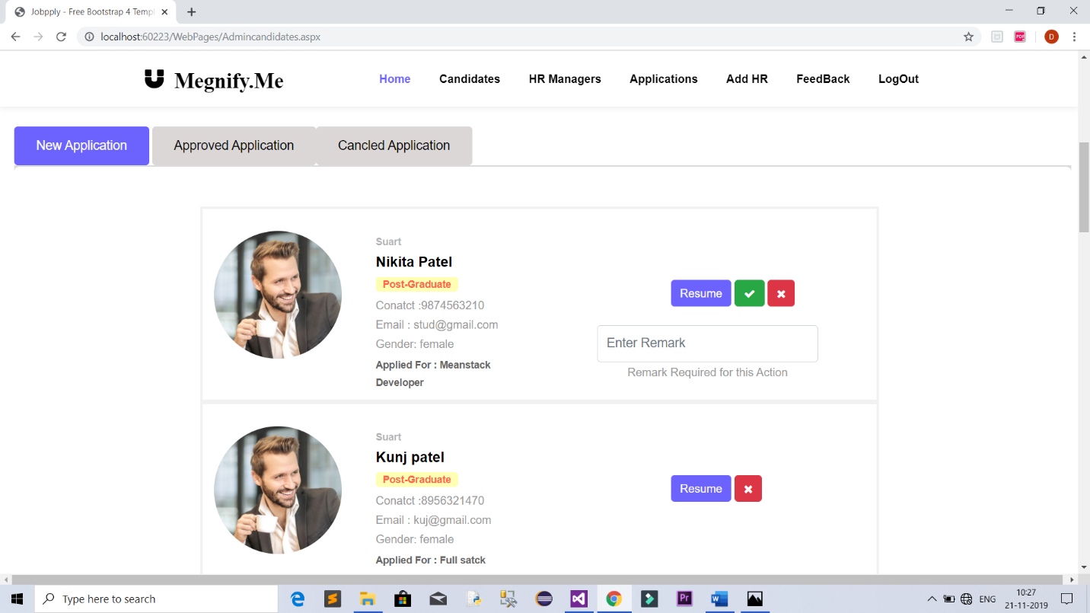

# 5.Future Enhancement of The Project and Conclusion

***Future* *Enhancement:***

* + - More efficient and easy to use.
    - Less redundancy.
    - Interviewing will be done after approval of application.

***Conclusion:***

* + - This system of an online job portal system where job seeker can apply for job from anywhere over the internet.

***Learning during the project work :***

* + - Pressure and confidence.
    - Self learning attitude.
    - Team work.
    - How to manage time.

# 6.References

* + - Text Book(Software Engineering)
    - Project Guide: Mrs. Preeti Bhatt

# 7.Bibliography

* + - [www.w3schools.com](http://www.w3schools.com)
    - [www.youtube.com](http://www.youtube.com)